Brandywine Trip InformatiN

The meeting place will be Shaw Bridge Park. 274 S. Creek Rd. West Chester, Pa.

Planned meeting time is 9:30 a.m. The shuttle is about 9 miles one way.

Directions

You can use Google or mapquest with destination 274 S. Creek Rd. West Chester, Pa.

Or

The directions using the Commodore Barry Bridge are the following. Take Rt. 295 in New Jersey to the Commodore Barry Bridge. Take I-95 South in Pennsylvania.

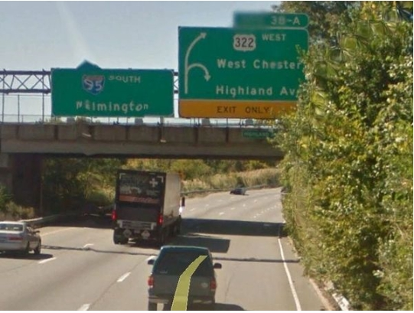  Take Exit 3 A of I 95 South in Pa.  This is the first exit after getting on I 95.  Note the split at exit. | 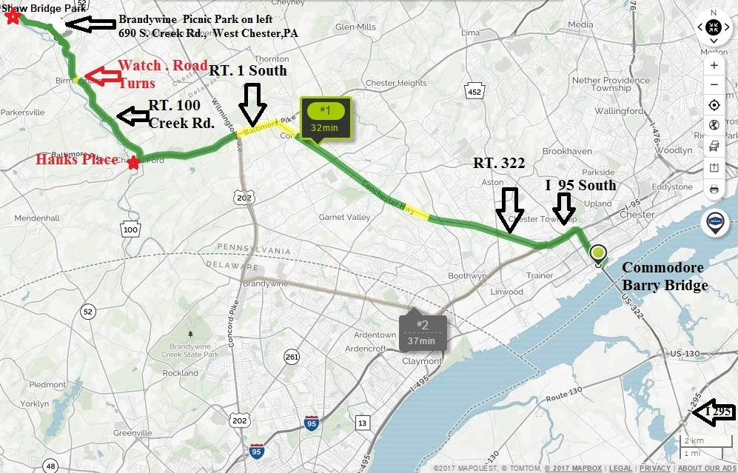

Stay on Rt. 322 for 7 miles to Rt. 1.

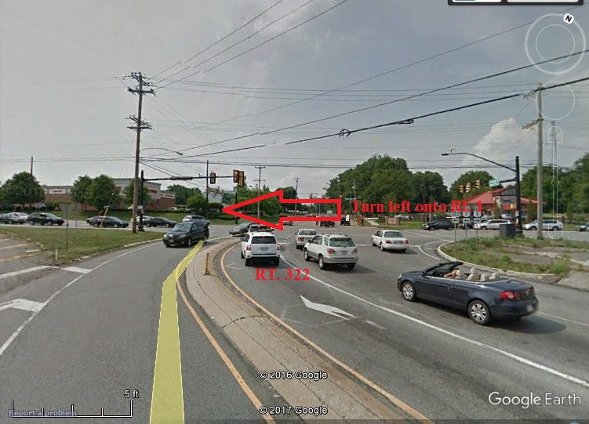
Turn left onto Rt. 1 south. Continue south for approx. 3.5 miles.

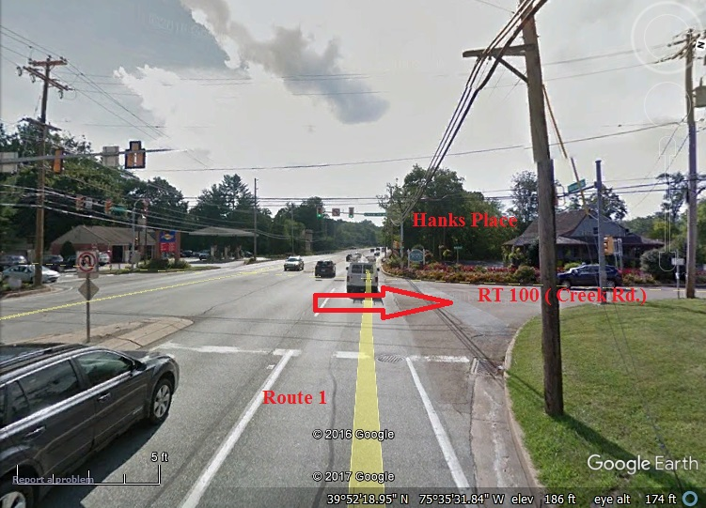
You make a right hand turn onto Rt. 100 (Creek Rd.) at traffic light (Hanks Place restaurant is on the right side and the Chadds Ford Post office is on the left side, the Brandywine River Museum (not visible from road) I s diagonally across intersection on left side of rt. 1.

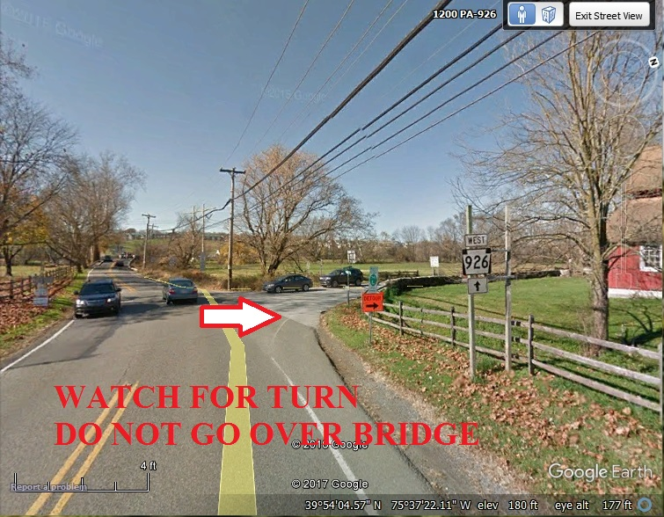TURN RIGHT

Take Rt. 100 approx. 4 miles. (watch for turns) (If you go over river bridge-you just missed turn)

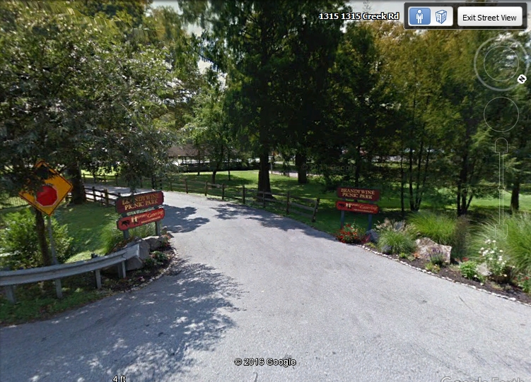

Continue past Brandywine Picnic Park for approx. 0.1 miles.

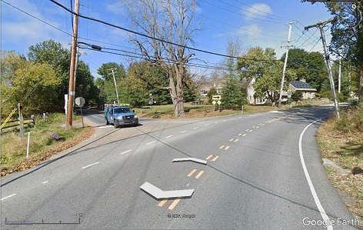
Turn Left onto S. Creek Rd.

Continue for Approx. 0.8 miles

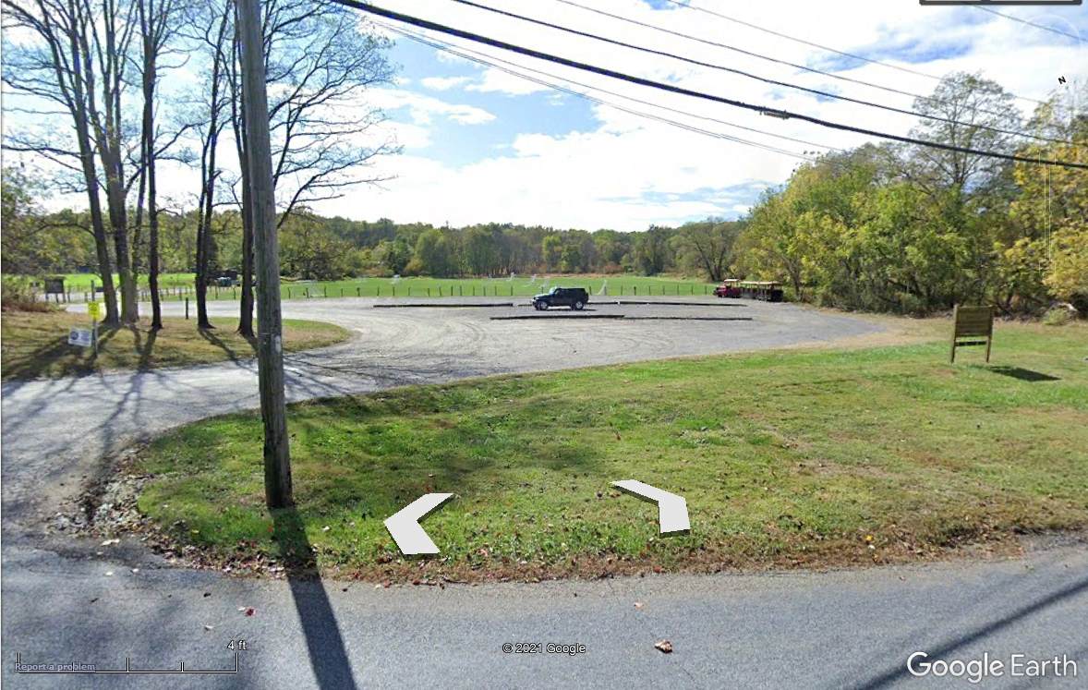

Arrive at Shaw Bridge Park on the Left
Note: Parking is limited

Take out will be at Smith’s Bridge in Delaware rather than Brandywine State Park. (More parking and no fee)

Trip Length is approx. 10 miles with 2 dams (easy portage of 1 first). The second Dam has recently required a portage because of downed tree; in the past, it was possible to run with class 1 rapids. Depending on water levels some easy riffles. Enjoy the scenery of the historic Brandywine Valley.
If you have canoe/kayak carrier, bring it. There is a carry of almost 700 feet to put-in from parking lot.

American Whitewater Brandywine River https://www.americanwhitewater.org/content/River/view/river-detail/11355/main

FOR BATHROOMS Pot-a pot will be available

Call if you have any questions 856-767-2780 or E-mail mailto:Hornet71@%20verizon.net
Trip day Cell 609-330-8029

